SQL QUERIES
1. Monthly Sales & Profit Analysis
SELECT
EXTRACT(MONTH FROM Order_Date) AS Month,
SUM(Sales) AS Monthly_Sales,
SUM(Profit) AS Monthly_Profit
FROM Orders
GROUP BY EXTRACT(MONTH FROM Order_Date)
ORDER BY Month;
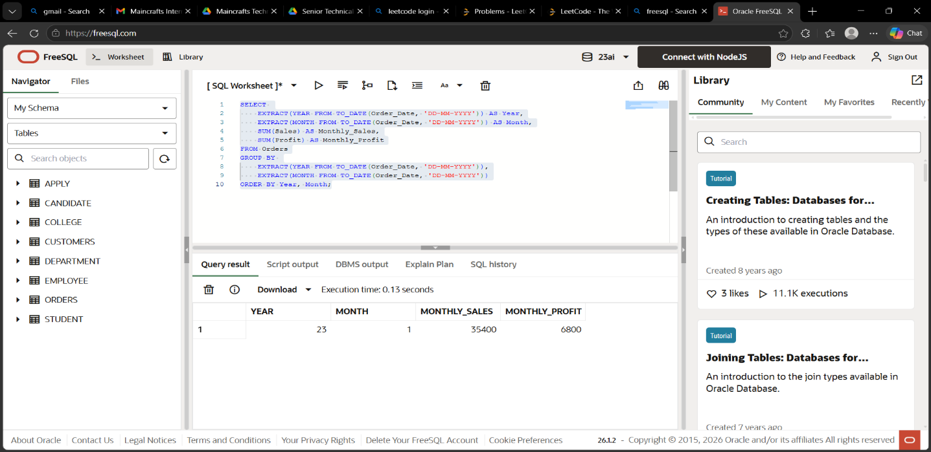

2. Monthly Growth Percentage (Subquery + Join)
SELECT
t1.Month,
t1.Monthly_Sales,
ROUND(((t1.Monthly_Sales - t2.Monthly_Sales) / t2.Monthly_Sales) * 100, 2) AS Growth_Percent
FROM
(
SELECT EXTRACT(MONTH FROM Order_Date) AS Month,
SUM(Sales) AS Monthly_Sales
FROM Orders
GROUP BY EXTRACT(MONTH FROM Order_Date)
) t1
JOIN
(
SELECT EXTRACT(MONTH FROM Order_Date) AS Month,
SUM(Sales) AS Monthly_Sales
FROM Orders
GROUP BY EXTRACT(MONTH FROM Order_Date)
) t2
ON t1.Month = t2.Month + 1;

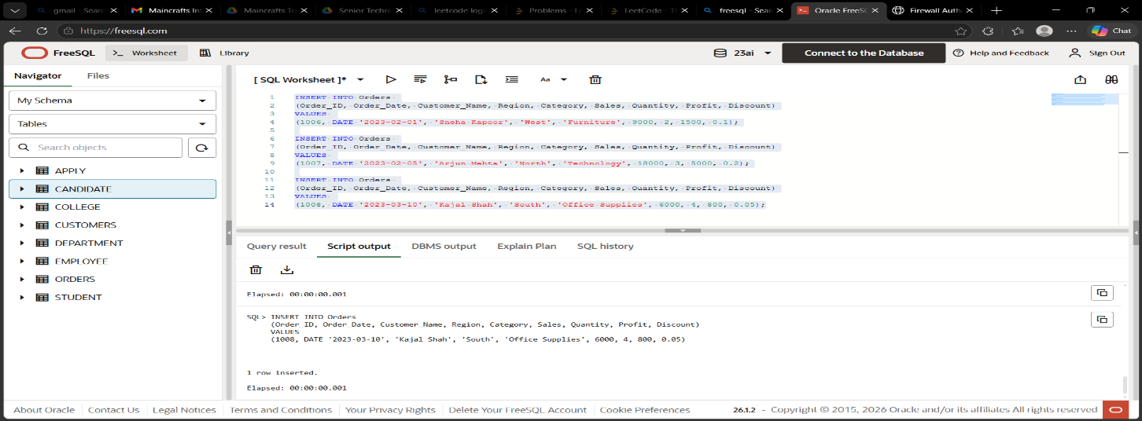
3. Order Classification using CASE
SELECT
Order_ID,
Sales,
CASE
WHEN Sales > 10000 THEN 'High Value'
WHEN Sales BETWEEN 5000 AND 10000 THEN 'Medium Value'
ELSE 'Low Value'
END AS Order_Type
FROM Orders;

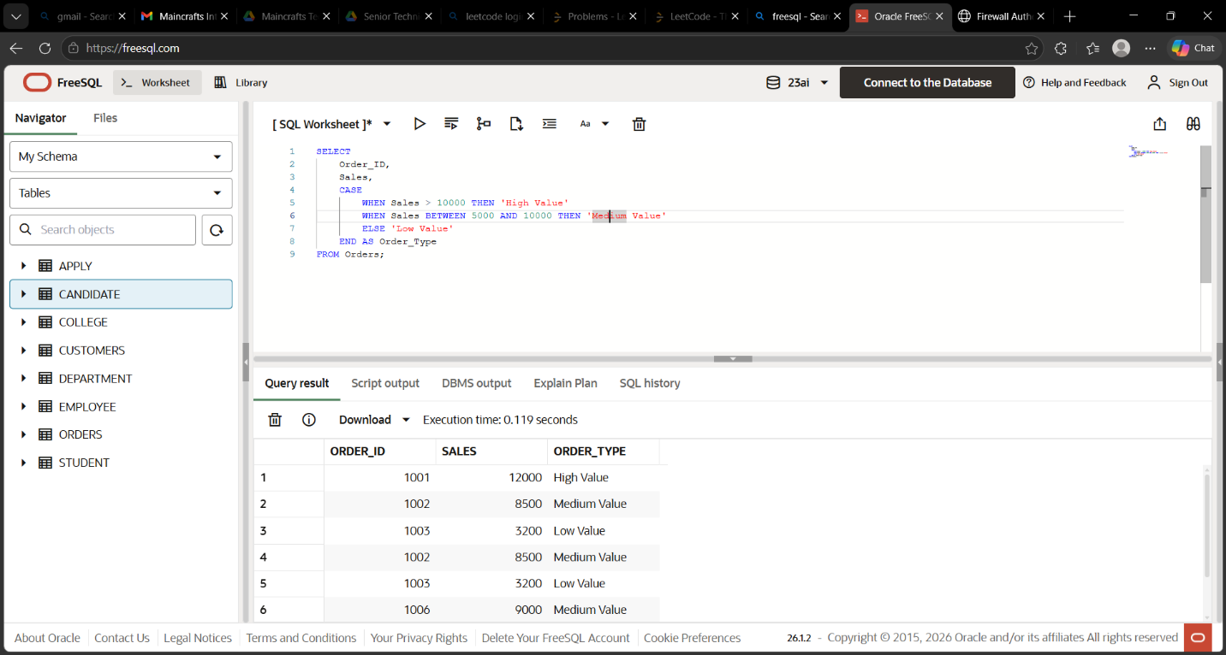
4. High Performing Categories (HAVING)
SELECT
Category,
SUM(Profit) AS Total_Profit
FROM Orders
GROUP BY Category
HAVING SUM(Profit) > 2000
ORDER BY Total_Profit DESC;

